Topic- Microservices with Spring Boot 3 and Spring Cloud  
Q) Creating Microservices for account and loan  
In this hands on exercises, we will create two microservices for a bank. One  
microservice for handing accounts and one for handling loans.  
Each microservice will be a specific independent Spring RESTful Webservice  
maven project having it's own pom.xml. The only difference is that, instead of  
having both account and loan as a single application, it is split into two  
different applications. These webservices will be a simple service without any  
backend connectivity.  
Solution:-  
Code:-  
AccountController.java  
package com.cognizant.account;  
import org.springframework.web.bind.annotation.\*;  
@RestController  
@RequestMapping("/accounts")  
public class AccountController {  
@GetMapping("/{number}")  
public Account getAccountDetails(@PathVariable String number) {  
return new Account(number, "savings", 234343);  
}  
static class Account {  
private String number;  
private String type;

private double balance;  
public Account(String number, String type, double balance) {  
this.number = number;  
this.type = type;  
this.balance = balance;  
}  
public String getNumber() { return number; }  
public String getType() { return type; }  
public double getBalance() { return balance; }  
}  
}  
OUTPUT:  
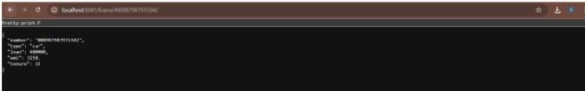

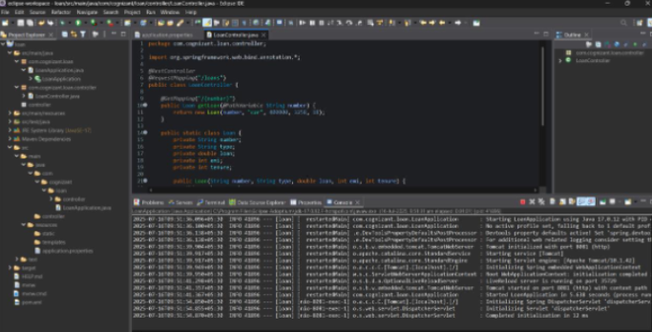

LoanController.java  
package com.cognizant.loan;  
import org.springframework.web.bind.annotation.\*;  
@RestController  
@RequestMapping("/loans")  
public class LoanController {  
@GetMapping("/{number}")  
public Loan getLoanDetails(@PathVariable String number) {  
return new Loan(number, "car", 400000, 3258, 18);  
}  
static class Loan {  
private String number;  
private String type;  
private double loan;  
private double emi;  
private int tenure;  
public Loan(String number, String type, double loan, double emi, int  
tenure) {  
this.number = number;  
this.type = type;  
this.loan = loan;  
this.emi = emi;  
this.tenure = tenure;  
}  
public String getNumber() { return number; }  
public String getType() { return type; }  
public double getLoan() { return loan; }

public double getEmi() { return emi; }  
public int getTenure() { return tenure; }  
}  
}  
OUTPUT:  
